OFFICIAL



HMCTS

Technology Strategy

**Digital and Technology**

**Services**



202

1

-

2023

Issue 1



# HMCTS Digital & Technology Services

HMCTS Digital & Technology Services (DTS) deliver digital services for internal and external users across courts, tribunals and all digital channels.

We drive the future of technology in HMCTS, working with colleagues throughout the organisation to provide innovative solutions to operational needs.



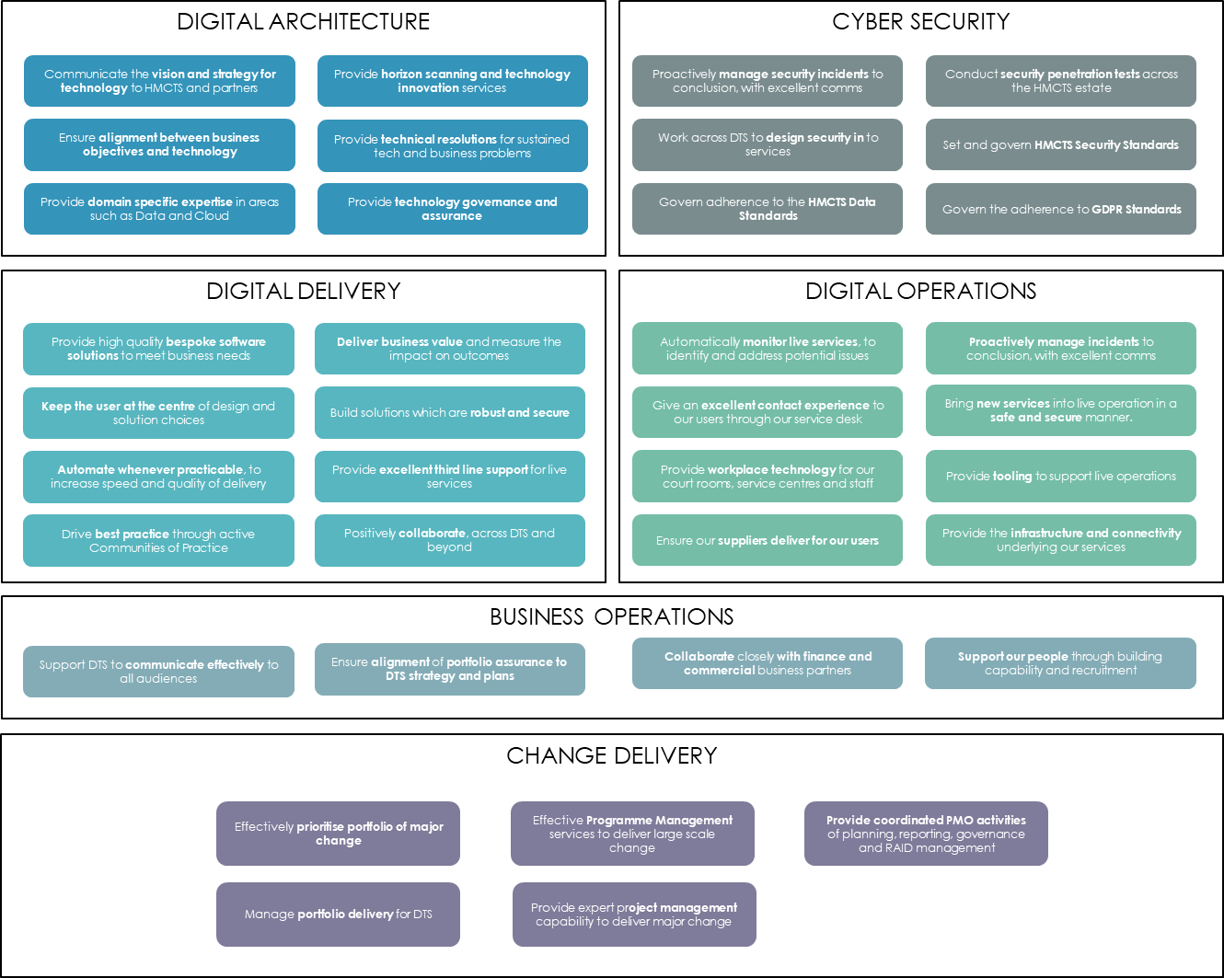

OFFICIAL

OFFICIAL



Contents



**I**

**-**

**Introduction to**

**HMCTS**

**Reform**

i

–

What is

HMCTS

Reform?

ii

–

Structure

of Reform

iii

–

Design Principles

**II**

**-**

**HMCTS**

**Technology Strategy**

i

–

What is the

HMCTS

Technology Strategy?

ii

–

Technology Principles

iii

–

Technology Trends

iv

–

Technology Vision

i

v

–

Strategic Priorities

v

–

Strategic Plan Summary

vi

–

People, Culture and Ecosystem

**III**

**-**

**Reform Digital Architecture**

i

–

Digital Reference Architecture Metamodel

ii

-

Digital

& Technical Reference Architecture

**IV**

**-**

**Appendix**

i

–

Terminology

ii

–

Digital Reference Architecture v1.

9

iii

–

Reform Integration Big Picture

OFFICIAL



Introduction to

HMCTS

Reform



Introduction to

HMCTS

Reform



What is HMCTS Reform?

We have been modernising our services since 2016, providing new, user-friendly digital services and improving efficiency at the same time. The original vision for reform - to modernise and upgrade our justice system so that it works even better for everyone - remains true. But we must recognise that the world has changed since 2016 - and rapidly so - as a result of the COVID-19 pandemic that started in 2020.

It is no longer visionary to have digital services and to use audio-visual technology at some point in the future; it is a necessity, here and now. It’s required if we want to keep pace with the modern world because it will not be possible to make future improvements if they are not underpinned by robust and resilient systems fit for today’s 21st century demands.

The Justice System by numbers:

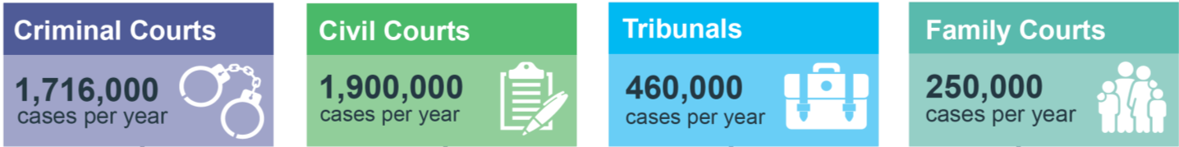

The Reform 202

3

Vision:

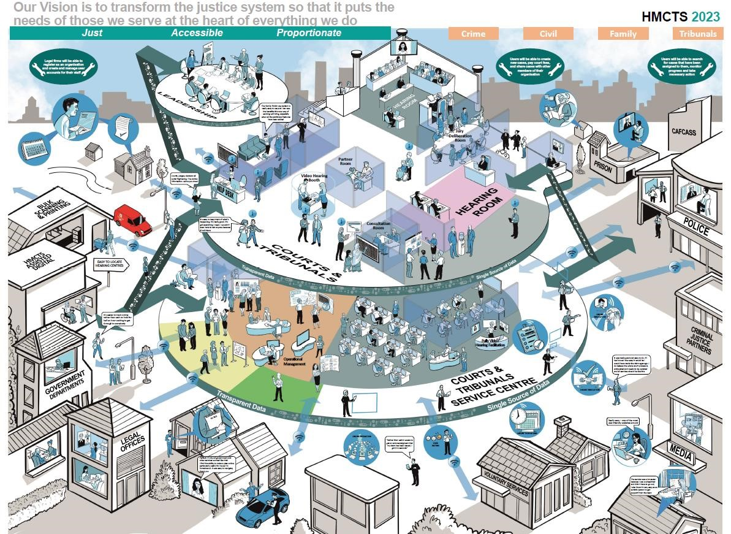

# The Structure of Reform

Reform is made up of

6

key programmes:

Crime

Programme

Future

Operations

Future

Hearings

Civil, Family &

Tribunals

National Tier Organisation Design

Property Transformation Programme



The aim of the **Crime Programme** is supporting digital working throughout the criminal courts by enabling all participants in the criminal justice system to work from the same information to reduce duplication of effort, introducing more consistent working practices, and allowing us to deal differently with things that don’t need to be in court.

The **Civil, Family & Tribunal (CFT) Programme** is delivering a range of digital services to support fair and speedy resolution of Civil, Family and Tribunal cases, such as divorces, adoptions and social security appeals.

**Future Operations** will deliver a new operating model and supporting capability to operations within our Courts and Tribunals as well as the Courts and Tribunals Service Centres (CTSCs), transforming operational ways of working. This includes the creation of centralised locations for contact and the support and administration of cases, in addition to enhancements for the front of house and on-the-day management of our hearing centres.

**Future Hearings** will deliver our new hearing scheduling and listing tools to provide efficiencies in the use of our resources, the publication of our information to the public and the press, as well as the use of video hearings.

**National Tier Organisation Design** will review the end-state national functions, incorporating national support and enabling functions, and national operational leadership, to ensure they have an organisational model that is efficient, effective, sustainable and “best fit” to fulfil HMCTS’ long term strategic vision.

**Property Transformation Programme** will improve the utilisation of HMCTS buildings, create new designs for courts and tribunals, and modernise our buildings.

# Reform Strategic Design Principles

The strategic design principles have been developed with the senior Judiciary to shape and steer the Reform programme. These principles are linked to the Target Operating Model and embedded into the design of each Reform Service.

## **1. A just system that is built in partnership with and around the needs of those who use it -** citizens, judiciary, business users, victims, witnesses and state users

1. **A system that is accessible -** easy to use, digital-first services which are accessible for non-digital users.

1. **A system that is proportionate and segmented -** with the ‘majesty of the court’ when needed and low cost, low burden channels, where speed and simplicity is what users want most.

## **4. Strengthening our strong, independent and trusted justice heritage -** with different

channels and experiences for different users.

1. **A system that is transparent, accountable and continually reviewed -** in its overall approach and use of technology.

1. **A system that is financially viable -** operating the system at lower cost with secure funding

1. **A system that is future proofed, designed for 2050 not 2015 -** with a flexible infrastructure to keep it relevant and accessible to our users

1. **A system with our people and its users at its heart -** a smaller and smarter workforce who are there for users when they need us

OFFICIAL

Page



HMCTS

Technology Strategy



HMCTS

Technology

Strategy



What is the HMCTS Technology Strategy?

The HMCTS Technology Strategy, managed by DTS Digital Architecture, articulates the principles and priorities that are being used to deliver robust and capable digital services which provide HMCTS’s future capability.

By clearly defining and communicating our vision for the digital landscape of the organisation, which underpins the realisation of the Target Operating Model, we will ensure that internal and external users understand both our end state and that we will ultimately reach it.

The HMCTS Technology Strategy is made up of five sections:

**1**

**. Technology principles**

that underpin our

Digital Services

**. Technology trends**

**2**

that provide opportunity or

impact to HMCTS

**3**

**. Technology vision and strategic priorities**

that

are essential to bringing Reform to life by 2023

**4**

**. Strategic plan**

summary for HMCTS digital and

technology

**5**

**. People, culture and ecosystem**

related to

technology at HMCTS

Footnotes within the document refer to the relevant strategy ID from the DTS Strategic Plan.

Page

# Technology Principles

Digital and technology solutions are at the forefront of delivering Reform. The design and development of these solutions are underpinned by a set of 9 Technology Principles:

**1. Be user and business centric**

Ensure clear alignment to business benefits and the needs of our users

## **2. Understand our data**

We will minimise data collection to avoid duplication, and document and understand our data to maximise its utility

## **3. Never compromise on security & compliance**

Keep systems and data safe, especially our citizen’s data, by following information assurance processes

## **4. Open source & open standards before COTS before custom-built**

We will use open standards to avoid vendor lock-in and ease integration and adaption before buying a product or building it ourselves

**5. Be leading edge, not bleeding edge**

We will use leading technologies, that have a proven track record

## **6. Cloud before on-premise**

A Cloud provided service should always be considered prior to on premise hosted options

**7. Be robust**

We will deliver solutions that meet service needs and can scale appropriately

## **8. Automate as much as possible**

Manual processes and procedures should be replaced by automated digital operations where possible

## **9. Share & reuse**

Our solutions will promote sharing and reuse across HMCTS and our partners

In addition to the principles and standards laid out in:

[GDS Technology Code of Practice](https://www.gov.uk/government/publications/technology-code-of-practice/technology-code-of-practice)

[DTS Sourcing Software Sourcing Approach](https://cjscommonplatform.sharepoint.com/:p:/r/sites/DACS-Home/DACS%20Published%20Content/DCD%20Software%20Sourcing%20Approach%202018-01.pptx?d=w971ebd039e4845db9ccb29bbbed002f4&csf=1&e=el6ckb)

# Technology trends that provide an opportunity or impact to HMCTS

|  |
| --- |
| Contract**Smart contracts**    With a smart contract, the terms of the agreement are written into computer code and execute automatically upon certain  events. Considerations include how legal interpretations and remedies are made by legal users and the judiciary. |
| Social network**Internet of Things**  Even more devices that contain sensors and are connected (such as cars and health devices) will continue to provide  unprecedented amounts of information which could be used and presented as evidence in our hearings. |
| Decision chart**Guided decision-making**  Data and analytical models are used to assess performance.  Using them actively to prompt and guide action at the right time will increasingly be effective in organisational decisions and workforce management. |
| Robot**Automated legal services**  Legal tech disruption will continue with the highly capable automation of the services being offered publicly – such as law  bots. To maximise their efficiency, the demand from professional users to integrate directly with our systems will increase. |
| Head with gears**Learning, self-repairing systems**  Artificial intelligence creates learning systems that improve over time and recover from failure, allowing business processes to be improved and automated where appropriate. Workforce intensive processes such as managing exceptions can be reduced. |
| **Anywhere Operations**  Map compass“Anywhere operations” describes an anticipated expectation from our users and our staff: for business operations designed to reach users anywhere, enable employees anywhere and use digital technologies to deliver business services anywhere. |

# Technology Vision

Introduction

By 2023, we will have built a modern and upgraded justice system that works better for everyone, including the judiciary, legal professionals, witnesses, victims, defendants, and our citizens. **To achieve this ambitious aim, we have a need to reduce the use of paper files, provide new digital services to our users, establish centralised services, and automate processes.**

**As a result, our service will have a significantly increased reliance on available and performant digital services:** we are moving to a new business model that fundamentally changes the role of technology in our operation. Substantial numbers of cases will move from being managed in a physical environment to a digital one, and therefore, the dependence upon a highly available, flexible and integrated range of technology is significantly increased.

The external users of our services (members of the public, professional users, and partners) will be utilising digital channels to submit applications, receive updates, and raise queries (although paper channels will still be protected for members of public)[1]. In addition, new enabling technology will be providing the scheduling and listing of hearings, and our ability to provide remote hearings. All of which further increases our reliance on technology to manage the flow of cases through the courts and tribunals system - which requires an increased investment in our platforms and our technology support teams.

Due to this increased digitisation, the need to **protect our digital systems, and the sensitive data** they hold, needs to scale in line. Advanced proactive and reactive cyber security capabilities are required to enable this protection, such as: the detection of vulnerabilities within our systems, the testing of our defences, and the monitoring for suspicious activity.

Some examples of reform and their technology impacts:

* **Courts and Tribunal Service Centres[2]** allows us to build centralised functions, giving citizens a tailored and accessible source of support, and allowing the consistent administration of cases through the legal process. A brand-new enterprise scale contact centre solution is being built to enhance our ability to manage user contact and progress work effectively
* The **scheduling and listing function[3]** will make use of a new digital service, enabling a single view to ensure the best use of our estate. This new service will enhance our ability to provide an end-to-end case progression service as well as provide our listing officers with more visibility and control. The data from this service will be crucial in providing insight and to support the future of listing policy
* The **video hearings service[4]** will enable the Judiciary to select hearings for remote participation, in order to provide more flexibility and an improved service to members of the public and professional users – whilst protecting the judicial process. The new technology will enable a seamless and simple service for all participants and will guard all Open Justice principles
* The **strategic data platform[5]** will provide a single location for the data and services that support the delivery of management information and strategic reports for the organisation. All relevant data will flow into this system so that expert analysis can draw insight for the organisation and the Judiciary. This new platform stores and protects this data and provides the right views of our data to those authorised.

These services are all crucially cross-jurisdiction and will transform our operation and management.

Technology Vision Headlines

* **We will deliver a series of new technology platforms designed on modern standards, shared components and interfaces designed for re-use.[6]** Our Reform cannot meet its ambition with incremental changes to existing systems, and therefore new systems are needed. These will enable the scalability, flexibility and performance required to make justice services easier to access for our users and transform our internal operation with paper-less processes.
* **We will offer a digital service to our users in the form of online interfaces[7]**, or APIs for direct system to system interaction – for those professional users or government partners who wish to make use of them.
* **Our new online services will be designed for ease of use, that are completely user centric[8]** – all complying with GDS standards. Based upon a common design language, we can deploy new services quickly and can ensure consistency for our large and diverse user base
* **We will build centralised case management systems[9]** to provide tailored case progression for each of our jurisdictions - which will enable the automation of processes, enable collaboration from all parties, and enable purely digital-inside working. We will retain two distinct case management systems for Crime and for the CFT jurisdictions, whilst maximising shared digital services between the two.
* **We will improve non-digital channels**7 - with our bulk scan service ensuring we can support all user needs whilst maintaining digital-inside principles. We will work hard to minimise scanning failures by redesigning the paper forms to make them more understandable and usable, whilst also making sure they are processable first time by our technology.
* **We will decommission our legacy technology estate, to save cost and minimise risk[10]**, by creating functional parity between old and new systems, followed by the transition, migration or archiving of data – maximising the value of our data whilst complying fully with regulations.
* **We will continue to leverage Cloud at pace[11]**. Cloud now plays a significant role within HMCTS, allowing us to concentrate on the delivery of business functionality as opposed to the underlying infrastructure services. We will work to optimise this environment to further minimise cost, whilst making use of the best service from the best Cloud provider.
* **We will become a data-driven organisation[12]**, with our Strategic Data Platform playing a crucial role in continuous improvement and helping us draw business insight. Data can be shared seamlessly between teams and exported externally as required for academic or governmental purposes.

# Strategic Priorities

To **enable** a justice system that works better for everyone we **must provide resilient, sustainable and cost effective digital and technology solutions**. The following priorities, which support our technology vision, are essential to building sustainable services and bringing HMCTS Reform to life by 2023:

Enhance the

**integration**

of our services & platforms to deliver truly end

-

to

-

end services

Be a

**data**

**-**

**centric organisation**

to improve performance and inform our decisions

Continue to drive the

**use of shared digital services**

and foster reuse

Improve our

**technology innovation capability**

to solve real operational challenges

Scale our

**Cyber Security & Information Assurance c**

apabilities to protect our services and data

Deliver a

**robust digital court and tribunal experience**

to enable effective justice

**Minimise our heritage technology estate**

and the associated risks and costs

Enhance our technical capability for

**in**

**-**

**house software delivery**

Enhance our ability to

**maintain and improve our digital services**

## Enhance our ability to deliver, maintain and improve our digital services

**Our Digital and Technology Services (DTS) directorate requires transformation to meet the increased reliance on technology and the scale of digital use derived by the Reform programme.**

As we move our core business towards digital services, DTS will need to transform as a result.

This transformation[13] will be realised through:

* **the formation of the digital delivery capability[14]** - needed to sustain and develop the digital services delivered by Reform as well as future services required by HMCTS
* **the increased size and widened skills of DTS to match the ambition of our transformation** – which, in addition to the new digital delivery function, will increase our digital operations function and introduce regional digital hubs to maximise our ability to recruit and retain specialist resource
* **the matured and improved way we deliver end-to-end support services[15]** - DTS will mature existing service support offerings and create new offerings where required, standardising and automating where possible whilst providing more flexibility where needed

**In order to deliver against this ambition there are some technology investments required:**

* **Application Performance Management**[16] **(APM)** will ensure we have full visibility of our technology estate, can diagnose issue more effectively, and can ultimately be proactive with handling technology incidents. In addition, APM is a tool to assist in the development of performant services. APM aims to provide: o Reduced downtime o Improved end-user services and experience o Service development o Reduced operational costs o Supplier accountability
* **Improved accessibility to support services**[17]to enable our users to raise issues and requests and access knowledge articles 24x7 through mobile devices as well as their desktops and laptops. This will include providing:
  + A single front door portal for DTS support services with a focus on self-service, with personalised dashboards of incidents and requests logged
  + Seamless single sign-on to the user portal
  + Provide a real-time view of the status of our systems to staff working across multiple devices and sites o Improved automated workflow of approvals
  + Multi-channel major incident communications utilising both push and pull notifications o Chat functionality so users do not need to ring into the Service Desk
  + Interaction using a chatbot which pulls on information from knowledge articles to respond to users with predictive intelligence response based on learning from user queries
* **A centralised view of our architecture, assets and configuration management**16 to ensure we know the scale, size and shape of our estate and ensure that changes are adequately managed o Establish an enterprise view of our organisation by modelling the complex relationships between business, application, data, infrastructure and security - establishing a single source of the truth
  + Gain greater insight by enabling us to consistently and effectively answer cross-cutting strategic questions from stakeholders and decision makers
  + Enable the identification of dependencies among processes, people, applications and IT infrastructure to

provide more effective technology change and the faster resolution of incidents

## Enhance our technical capability for in-house software delivery

**With the formation of our digital delivery function, we must enhance our tools, standards and processes to ensure we can deliver excellent digital services to our users. The following principles will guide the development of our software delivery**

**function:**

* **Following GDS advice**, where it exists and is applicable, will assist in creating uniformity across government services, allow HMCTS to benefit from proven methods and expert advice and expedite the approval process where compliance is required. GDS peers will be involved in the governance process, and as required throughout the SDLC.
* **Build for the cloud**, to enable us to respond faster to the changing environment in which we operate and reduce costs. To maximise the cloud offering, Platform as a Service (PaaS) products will be preferred.
* **Approved technology stacks**, covering programming languages, runtime environments, frameworks, libraries and repositories, will be constantly reviewed to ensure HCMTS uses the most appropriate tech stacks for its needs:
  + A ‘horses for courses’ approach, allowing delivery teams to use the most suitable technology stack and propose new technology stacks when required
  + Focusing on a core selection of technology stacks to drive expertise, efficiency, uniformity and an increased time-to-market
* **Development/testing tools** will be provisioned to ensure the productivity of coders is maximised and to develop expertise in using tools such as Integrated Development Environment (IDE), Source Control, API Inspection, Packet Analyser and Package Manager. Reasonable effort will be made to accommodate coders that can increase their productivity using tools different to the ones provisioned. Sufficiently resourced local development environments (e.g. laptops) using modular components (e.g. containers) will allow staying mission-focused and maximise time invested.
* **You build it, you run it**. Teams will have the autonomy they require to own the end-to-end process, from building through to supporting their applications. CI/CD pipelines and Release strategies, such as Canary, Blue/Green and Versioned, combined with phased rollout approaches like Private Beta and Feature Flags, will allow delivery teams to practice Agile better. Infrastructure as code will allow teams to spin up environments as required and maintain them.
* **Just enough design** will be done throughout the SDLC in line with Agile and within the guardrails provided by the Technical Guidance Library and the technical governance. Software design will into account Domain Driven Design, Integration Patterns and

Distributed Computing, Software Architecture

Patterns, Design Principles, Design Patterns,

Programming Paradigms and Software Quality Attributes. Fitness functions will measure implementation against their design artefacts and the wider ‘guardrails’, and automated to continuously assurance and discover the estate.

* **Secure design and coding** will assure Information Asset Owners, users and other stakeholders that their data is in safe hands. Designing with security in mind from the outset will reduce risks and allow operating in an Agile manner. Code made publicly available will follow a robust process covering code quality and security.
* **Emphasis on code quality** will be assisting to reduce the learning curve of new joiners and increase the versatility of our coders. To achieve code quality, a combination of automated tools, regular reviews and upskilling will be used.
* **Prototyping** will be used to adopt a more Agile environment, reduce risks and increase stakeholder engagement.
* **Shift left testing** will be practiced, involving testing from the initial stages of the development in order to ensure that development efforts are focused on the requirements and increase the quality of our products. Automated testing will be preferred, and where possible designed to run in ‘headless’ mode and within the release pipeline.
* **Rapid application development (RAD)**, will allow the delivery function to increase its capacity and address additional target audiences. RAD will be treated as a first-class citizen within the delivery unit and seen as software development for all intents and purposes. RAD will be delivered using a wide range of tools including Robotics Process Automation (RPA), Workflow, Business Process Modelling and Notation (BPMN), Extract Load Transform (ETL) and scripting. Digital Delivery will serve as a Centre of Excellence, guiding Citizen Developers across HMCTS using lowcode technologies.

## Minimise our heritage technology estate and the associated risks and costs

**Most of our current technology solutions cannot support the Reform ambition, would need substantial investment if maintained, and are therefore being replaced.**

The current aging technology solutions have, in most areas, digitised the previous paper-based processes and therefore major changes are required to support the transformative operating model set out by Reform.

These legacy solutions are not to be considered modern, which results in our current costly support and change model with increased availability and cyber security risks. Even with substantial investment, these legacy systems will not meet the flexibility and scalability requirements that Reform is invoking.

We are replacing these systems with modern, cloud-based applications that will allow us to continuously improve our services, scale up as demand changes, and be cheaper to operate. In most cases we have chosen to develop custom services (in line with GDS principles) due to a lack of appropriate commercial products and the need to provide a user centric offering. For more standardised requirements (such as our contact centres) we are leveraging services provided by third parties, rather than developing bespoke services.

Once all business and technical functionality is delivered into our new Reform systems, most of our current legacy technology will require decommissioning – in order to minimise cost and risk.[18] A direct dependency on our ability to decommission (other than functional parity between the old and new systems) is the transition, migration or archiving of data away from the current systems. 19 Any retained heritage systems will require investment to continue to provide a robust service to our users.[19]

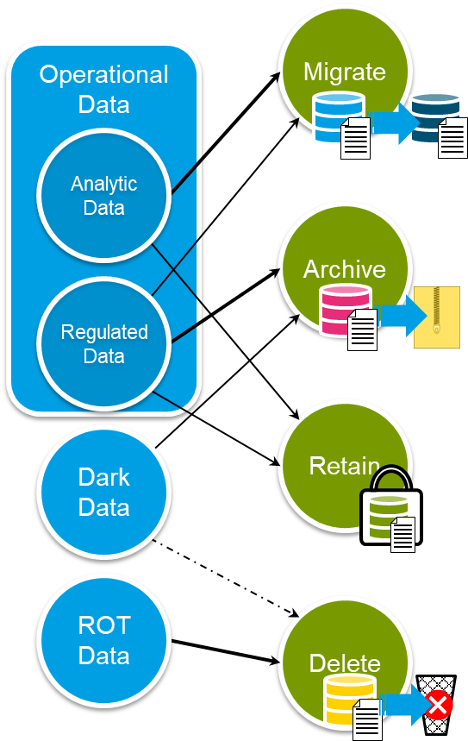Work is underway to analyse the data, design the data transition approaches, and deliver a data archiving solution.

**DTS Future Systems Programme**

It is within the scope of the Reform programme to provide an end-to-end digital service solution to enable the relevant heritage systems to be decommissioned. The DTS Future Systems programme will enable legacy decommissioning through the following set of activities:

* Working with Reform to confirm timelines and plans to close gaps in functionality to enable decommissioning
* Detailed review of each heritage system to determine a priority ranking, with a risk-based mitigation strategy and plans where Reform functionality will not be delivered in time to avoid remediation work on the legacy estate
* Determination of the data migration strategy, data analysis of our legacy systems, the design of data transition approaches and implementation of data migration requirements
* Determination and implementation of a suitable archiving solution to ensure we meet GDPR regulations and retain necessary data
* System decommission planning and implementation

*Figure 1 - Data transition options*

## Deliver a robust digital court and tribunal experience to enable effective justice

**To ensure the very best experience for our in-court users, both citizens and professional users, we must design effective, resilient and performant technology solutions that underpin our digital services.**

Understanding how the Courts and Tribunals of the future will consume Reform digital solutions is crucial to ensuring Reform’s vision. Services such as Digital Check-in, Video Hearings, centralised Listings and digital case files all change the way the courts and tribunals will operate and increase the reliance on technology for us to administer justice.

**Digital Courts Vision[20]:**

* **Wi-Fi and networks** o Deliver resilient, full-building Wi-Fi coverage to all courts and tribunals buildings to support our transformation - that is simple for all users to access and can support the enhanced use of digital material
  + Converge network bearers and endpoints to reduce cost and simplify support
* **Video/Audio** o Ensure the judiciary can permit remote participation in their hearings – with the ability to swiftly re-arrange a hearing to have one, more or all participants on video or audio, in either a hybrid or remote manner, in response to events – such as travel issues, weather, or illness/self-isolation that would prevent physical attendance.
  + Protect open justice by providing solutions for third parties to observe open/public hearings which are equivalent to or better than attendance at court. This is integral to the underlying business strategy for remote participation
* **Evidence Presentation** o Ensure that digital evidence can be viewed by all participants, either in-court or remote.
  + Ensure that digital evidence, such as video or audio product, can be presented in-court by representatives at a quality that meets judicial standards. Remote presentation of evidence should be supported where practicable (such as pre-hearings). o Deliver a digital audio and video distribution and recording services in each courtroom, to replace the aging and non-compatible analogue systems.
* **Partner enablement** o Enable our partners to utilise the court and tribunal infrastructure to enable their business processes, such as their own printing services or end user compute devices.

## Scale our Cyber Security & Information Assurance capabilities to protect our services and data

The business objectives for our services will be at the heart of our Cyber Security Capabilities. We will support the needs of our business, with the principle aim of enabling a safe and effective digital journey for all users. At the core of this we will:

* Ensure that systems and service are Secure by Design, by embedding core and repeatable design principles within the culture and mindset of colleagues charged with developing our digital services.
* Design and build the security of our systems and services in a modular fashion so that our security posture can adapt as threats evolve.
* Be proactive in our design decisions and constantly review and evolve our approach to protection, detection, response and recovery.

The Cyber and Information Security Capabilities[21] will be applied to ensure a holistic approach, and consist of:

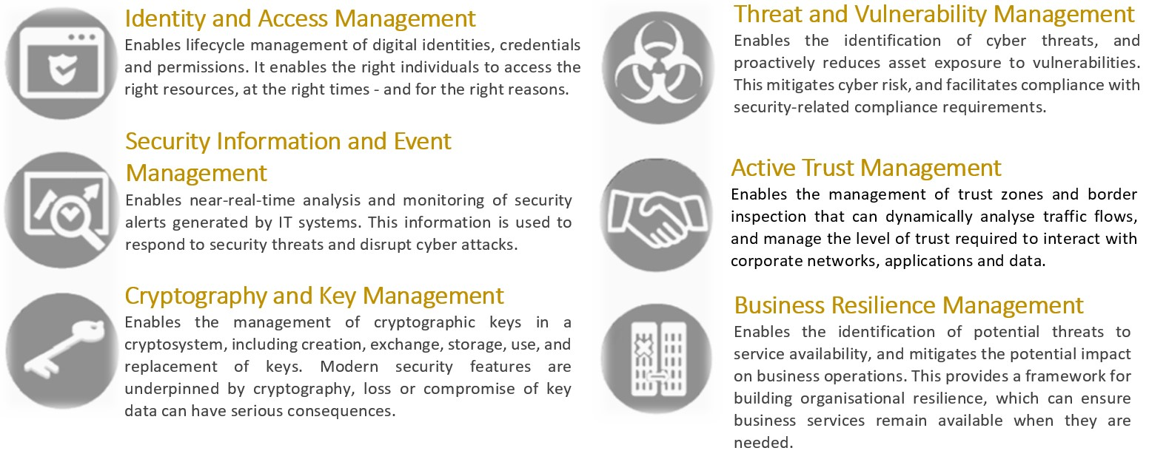

Our Technology choices will be underpinned by the following approach to embedding cyber security effectively:

**Automation**[22]: We will embed automated tooling and associated processes to identify and design out vulnerabilities.

**Open Standards**: We will consider open standards, where possible, when designing the security of our systems and services.

**Increased Collaboration**: We will work harder to establish partnerships and dialogue with colleagues both within the public and private sectors to share best practice and learn lessons for increased cyber resilience within digital services.

## Improve our technology innovation capability to solve real operational challenges

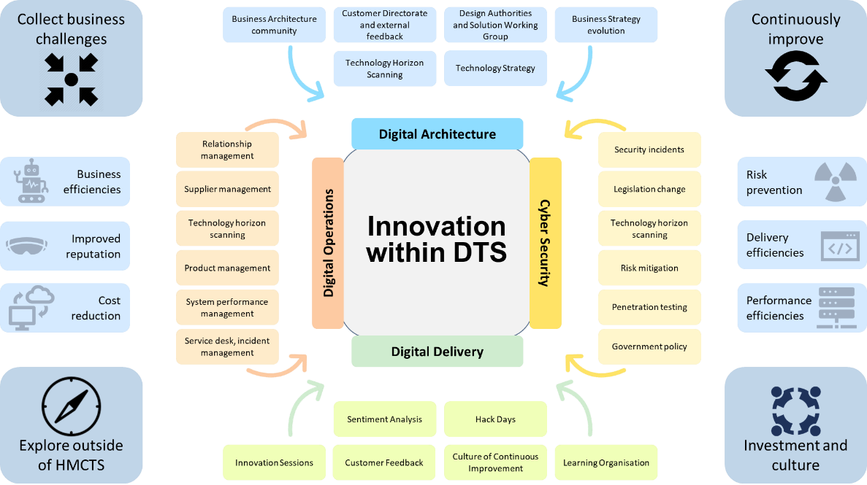**A mature technology innovation function is crucial in enabling us to solve some of its most pressing challenges, keep pace with the changing technology landscape, and keep our staff engaged. Innovation will help to minimise our risks, improve our delivery, and increase our performance - whilst helping to reduce cost and improve our reputation.**

Examples of innovation opportunities include the use of Machine Learning on-top of our bulk scanning service to reduce the exception queues within CTSC, and the use of AI transcription services to assist with hearing transcription services.

*Figure 2 - DTS innovation overview*

Innovation within DTS[23] has three phases: **Collect**, **Explore & Define**, and **Implement & Review**. Our strategy teams may start the process with *Collect*, whilst our delivery teams may start with *Explore & Define*.

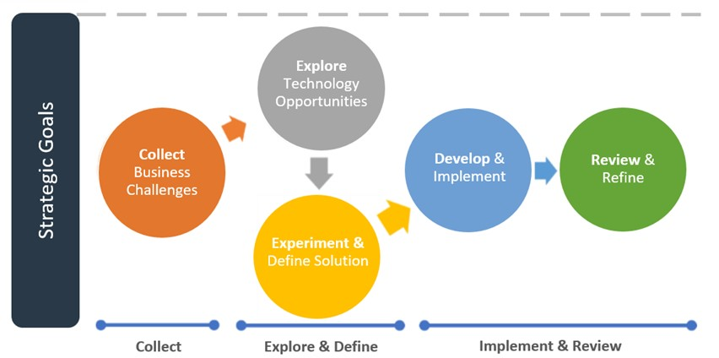

*Figure*

*3*

*-*

*DTS Innovation Approach*

* **Collect** and identify operational business challenges and pressures that DTS can have a meaningful impact on, docking into the wider business strategy of HMCTS
* **Explore & Define:** o **Explore** technology solutions and identify new or disruptive technologies
  + **Experiment** with its function, understand its impact and **Define** the solution to be developed
* **Implement & Review:** o **Develop** the technology in our setting, integrated with our test services, ahead of **Implementing** the concept adding value to both ourselves and to our users.
  + **Review** the technology in application and **Refine** its use for sustainable value

## Continue to drive the use of shared digital services and foster reuse

**As services such as Strategic CTSC come online, there is an even greater need to bring key Digital Services together, serving both jurisdictions in a common and consistent way.** **Shared Digital Services are digital services used by all jurisdictions within HMCTS.[24]**

These Shared Digital Services will drive reuse and reduce duplication across the organisation – and with our partners such as MoJ. This will in turn, reduce development and support costs and improve overall delivery.

Delivering Shared Digital Services

is a

non

-

trivial exercise

due t

o

the

added challenges of a doubly

complex user environment,

conflicting requirements and

intricate dependencies.



Crime Services



Shared Services



CFT Services

Technology Sharing &

Reuse

Truly Shared Services

e.g.

CTSC, Scheduling & Listing,

Workflow, Enterprise Search,

Integration, MI



Digital Service

**Delivery of shared services is a must and not optional for the organisation to deliver its benefits**. Principles to guide the delivery of our Digital Services:

* Our Digital Services exist within a continuum that describes the extent to which the services patterns, technology or instance is shared between multiple jurisdictions or business functions.
* In an ideal world all Digital Services would achieve some level of sharing of capability from a Software Engineering perspective and this level of consistency should already be expected and achieved by the Reform programmes.
* Transitioning beyond this basic-level, services should seek to make use of the same technologies e.g. Camunda – even if capabilities can’t be consolidated into a single instance.
* Aiming to provide a single instance of a capability should always be the starting point when establishing new digital services. From this starting position, effort, and therefore cost, can be saved in all programmes and maintainability post-deployment is significantly improved.

## Be a data-centric organisation to improve performance and inform our decisions

**Our joint business and technology ambition is to improve our capability so that data drives our performance, informs our decisions, and is at the core of our post-Reform world. We need to utilise our data to deliver efficient and high-quality services, transparently share with partners, and to invite business insights.**

Our Business Data Strategy has set the top-down agenda for data during and beyond Reform, driven by the Data Governance Authority. The strands that form the strategy are:



A significant proportion of the scope of the strategy sits outside the technology domain, tackling the exploitation of data and the business and cultural aspects. However, there are significant technology and architectural foundations[25] that support and enable the Business Data Strategy, such as:

* **Development of a strategic data platform**[26] that is capable of ingesting data from the broad range of source systems in our technology estate – both heritage and Reform and bringing it together to underpin management information, business intelligence and reporting. This will be based on the Microsoft Synapse product to deliver a combination of the structured data warehouse and Big Data characteristics (which will enable us not only to deliver efficiently with our regular structured operational MI) and reporting but also allow us to exploit data in new ways as our capability grows.
* **Development of processes and tools to enable active management of our most important reference and master data sets**27which will drive consistency across our systems, reduce the overhead of management of multiple data sets and simplify analysis and reporting. We will start with a limited offering of core services to store and serve data, working with the most important shared data e.g. locations to prove the concept and demonstrate business value.
* **Creation of a consolidated, consistent set of metadata** for the new platforms being developed, ensuring that we understand the data we have and its provenance and lineage such that we exploit and use it appropriately.
* **Definition of standards and patterns for our data models.**28 Although data structures and models will necessarily be defined by the needs of individual services, we will introduce convergence where possible to enable consistent analysis and evaluation to be performed. The set of Essential Data Items defined by the business is being refined and aligned with the data models within services
* **Development of approaches to enable managed sharing of data with others[27]** recognising that there is demand for data to support and demonstrate transparency which must be balanced with the controls to ensure privacy and security.

This will be underpinned by the introduction of governance, tooling and process that will increase our level of maturity to deliver benefit beyond Reform. As part of this work we will continue to build the reference views of our data estate that will

sit alongside the Digital Reference Architecture to enable analysis and decision-making within the Programmes and that will underpin governance and support of the platform in the longer-term.

## Enhance the integration of our services and platforms to deliver truly end-to-end services

**Reform Technical Integration[28] can be broken down into four major areas: CTSC integration; Scheduling & Listing integration; external integration; and supplementary integration. The major integrations would be those related to CTSC and Scheduling & Listing.**

**CTSC Integration[29]**

The integration between the Courts and Tribunal Service Centre and our two case management systems is focussed on the movement of tasks or activities that CTSC staff are required to complete. No case information flows between the case management systems and the CTSC system, other than a case reference number and basic tasking information. All case related data remains in the relevant case management system, where it is protected and audited. Once this task is received by the CTSC, the user will complete the required action directly inside the relevant case management system, before closing the task inside of the CTSC platform. This ensures that the CTSC have one single task list, whether the activity is derived from phone calls, instant messages, or this system integration.

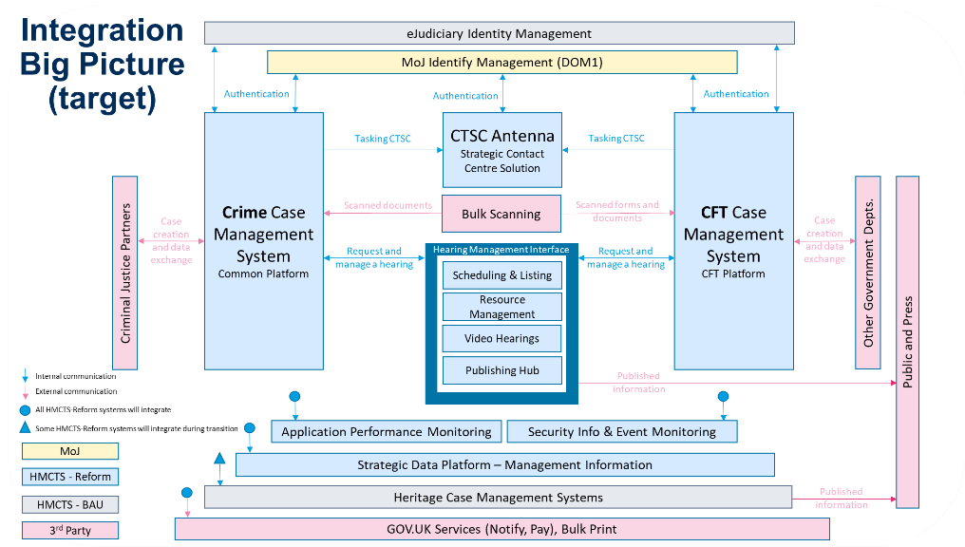

*Figure*

*4*

*-*

*Reform Integration Big Picture. Larger version in appendix*

An example would be the failure to scan a document that has been posted to us. If, as an exception, our systems cannot identify the document or form that has been sent, we may require human intervention to categorise it correctly. In this case, the case management system would send a task, along with the relevant link to the document, to the CTSC product. The CTSC staff would open the link to the case management system, categorise the document and then return to CTSC system to close the task and continue working.

**Scheduling & Listing Integration**[30]

The integration between the Scheduling & Listing service (alongside all systems within this ecosystem such as resource management and publishing) and the case management systems is focussed on the requesting and management of hearings. The case management systems will be able to produce a hearing request and send it to the Scheduling & Listing service, which will then return a response. Basic management or changes of hearings can also be done via this mechanism. Advanced Scheduling & Listing activities will be completed directing inside the Scheduling & Listing tool by trained power users. No case related information, other than the requirements for a hearing, are passed to the Scheduling & Listing tool – this data would remain inside the case management system for protection and audit.

|  |  |
| --- | --- |
| **External Integrations**  These are integrations between our case management systems and partner organisations. These allow us to automate the creation and management of cases and removes the need for email or non-digital channels. These integrations are protected, monitored and audited, and are only providing certain functionality to those that are authorised. | **Supplementary Integrations**  These cover mostly internal integrations - such as the ability to monitor our estate, authenticate our users, capture security audit information, or capture management information. There are integrations here with our heritage (i.e. current technology) systems whilst in transition (these are expected to be removed as heritage decommissioning occurs). |

# Strategic Plan Summary

*DTS Strategic Planning* is used to manage our Technology Strategy by defining and communicating the strategies and initiatives of DTS firmly connected to the business vision and goals of HMCTS.

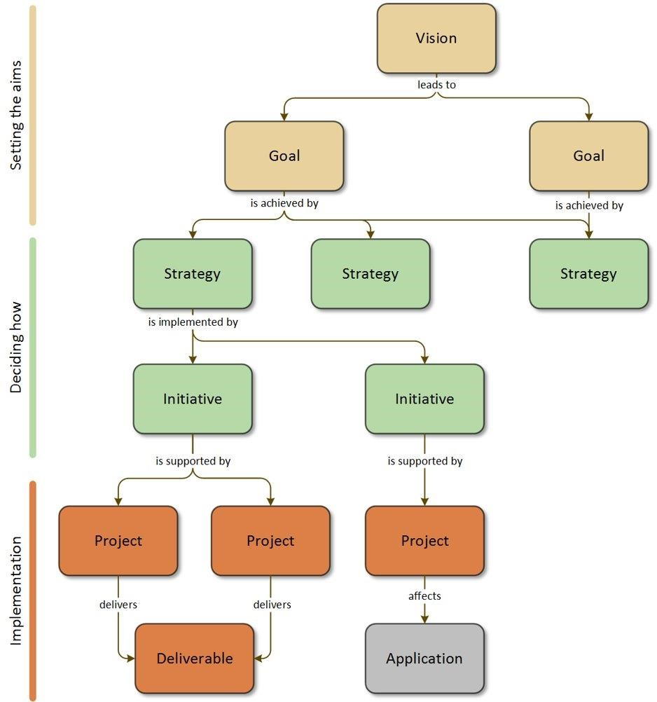Strategic Planning is a tool for:

* establishing the technical strategy **with direct alignment** to business vision and goals
* ensuring we’re doing the **right things at the right time**
* showing our teams **where their work**

**fits in**

* clearly connecting strategy to delivery **with traceability** to business drivers

for each development or transformation

* **keeping a strategy alive**, and not shelf-ware
* **communicating**, to the entire organisation, the direction of our technology and our function
* ensuring that new initiatives are **valid and necessary**
* providing a framework for **assessing**

**new requirements**

The following is a summary from the strategic planning model, showing the Vision, Goal and Strategy components of the model. The model contains a further 156 initiatives which describes specific work that need to be delivered.

**Vision: To modernise and upgrade our justice system so that it works even better for everyone**

G01 Improve a citizen's access to Justice and the experience of professional users interacting with HMCTS Services

S002 Accelerate the digital uptake of our digital services whilst maintaining paper channels

S003 Invest in tooling to efficiently schedule and list our hearings across our physical and virtual estate

S004 Enhance the ability to conduct hearings with remote participation

S012 Invest in our heritage IT estate to ensure effective business as usual for our citizens, professional users, and internal users- during and post Reform

S019 Invest in horizon scanning and technology innovation practices​ to ensure HMCTS is matching pace to technology, societal and legal changes

S040 Enhance the integration of our services & platforms to deliver truly end-to-end services

S041 Deliver centralised case management systems to provide tailored case progression for each of our jurisdictions

S042 Provide the best mix of channels for our users to meet their needs, self-serve where possible, minimise the number of contacts, and be cost effective

G02 Improve the experience of citizens and professional users using our local court and tribunals facilities

S003 Invest in tooling to efficiently schedule and list our hearings across our physical and virtual estate

S004 Enhance the ability to conduct hearings with remote participation

S013 Improve the user experience of using our local courts and tribunals through effective technology

S019 Invest in horizon scanning and technology innovation practices​ to ensure HMCTS is matching pace to technology, societal and legal changes

G03 Improve case progression and customer contact efficiency and consistency

S002 Accelerate the digital uptake of our digital services whilst maintaining paper channels

S012 Invest in our heritage IT estate to ensure effective business as usual for our citizens, professional users, and internal users- during and post Reform S017 Increase our efficiency through shared capabilities across jurisdictions

S019 Invest in horizon scanning and technology innovation practices​ to ensure HMCTS is matching pace to technology, societal and legal changes

S020 Provide tools to the CTSC to enable effective handling of external user queries

S040 Enhance the integration of our services & platforms to deliver truly end-to-end services

S041 Deliver centralised case management systems to provide tailored case progression for each of our jurisdictions

S042 Provide the best mix of channels for our users to meet their needs, self-serve where possible, minimise the number of contacts, and be cost effective

OFFICIAL

|  |  |  |  |  |  |  |
| --- | --- | --- | --- | --- | --- | --- |
| G04 Enhance our ability to deliver and sustain excellent digital and technology services | | | | | | |
| S001 Invest in tooling to ensure the effective management and support of our digital estate  S010 Implement the migration and archiving of data from heritage systems in order to enable decommissioning.  S011 Reduce the technology estate through decommissioning and consolidation to minimise cost and increase supportability  S012 Invest in our heritage IT estate to ensure effective business as usual for our citizens, professional users, and internal users- during and post Reform  S014 Provide consistent technology standards, patterns, and services to improve reuse, reduce duplication, and improve sustainability S016 Invest in platform and hosting technologies to provide resilience, stability and insight  S017 Increase our efficiency through shared capabilities across jurisdictions  S018 Refresh HMCTS Cyber Security Strategy and implement improvements  S019 Invest in horizon scanning and technology innovation practices​ to ensure HMCTS is matching pace to technology, societal and legal changes S022 Develop clear financial budgeting management and accountability  S024 Develop automated testing of security across our estate  S025 Improve our governance, risk management, compliance and permit to operate processes  S027 Provide the future technology and digital vision and strategy for HMCTS  S028 Invest in tooling across HMCTS for effective collaboration, knowledge management, and document management  S029 Improve our ability to measure and report on the effectiveness of our digital technology and services  S030 Accelerate the recruitment of civil servants into key roles to support our new ways of working  S031 Develop a workforce strategy and plan to ensure DTS has adequate resources in short, medium and long term  S032 Enhance the operating model of DTS to become the centre of excellence for digital change and delivery  S033 Invest in regional accommodation for DTS staff to establish our Digital Hubs  S034 Invest in technology and capability to enable our staff to work remotely  S035 Support operational needs during the COVID-19 measures, ensuring that appropriate capability is extended and created where practicable  S036 Understand staff and end user needs to drive excellent service across everything we do  S037 Establish and run a service to provide portfolio visibility of all DTS programmes and projects  S038 Take ownership of reformed services, ensuring that they meet the required standards and are actively improved  S039 Provide staff with a single front door for DTS including self-service and personalised technology support  S043 Develop technologies for rapid application development  S044 Develop technologies to enable business process automation | | | | | | |
|  | | | | | | |
| G05 Improve the utilisation and efficiency of our physical court and tribunals estate | | | | | | |
| S003 Invest in tooling to efficiently schedule and list our hearings across our physical and virtual estate  S004 Enhance the ability to conduct hearings with remote participation | | | | | | |
|  |  |  |  |  |  |  |
| G06 Enhance our cyber security capabilities to minimise risk and protect our digital estate and citizen data | | | | | | |
| S012 Invest in our heritage IT estate to ensure effective business as usual for our citizens, professional users, and internal users- during and post Reform S018 Refresh HMCTS Cyber Security Strategy and implement improvements | | | | | | |
|  | | | | | | |
| G07 Improve the transparent publication of data to the public | | | | | | |
| S015 Provide a central distribution hub for the publication of information to the public and other 3rd parties | | | | | | |
|  |  |  |  |  |  |  |
| G08 Provide efficient, high-quality and transparent services through data-centric capabilities | | | | | | |
| S005 Establish data curation capabilities to ensure we have the data we need, that it is structured and defined properly to enable its use  S006 Provide effective data analysis and modelling capabilities to deliver consistent and reliable information and to enable development of new insights S007 Develop the right data skills and culture to drive confident use of data throughout the organisation  S008 Invest in data architecture to deliver high quality, efficient and consistent services  S009 Enhance the ability to share our data to support transparency and enables others to innovate  S010 Implement the migration and archiving of data from heritage systems in order to enable decommissioning.  S019 Invest in horizon scanning and technology innovation practices​ to ensure HMCTS is matching pace to technology, societal and legal changes | | | | | | |
|  |  |  |  |  |  |  |
| G10 Enhance our workforce, with skilled and engaged employees with the tools they need | | | | | | |
| S006 Provide effective data analysis and modelling capabilities to deliver consistent and reliable information and to enable development of new insights S007 Develop the right data skills and culture to drive confident use of data throughout the organisation  S019 Invest in horizon scanning and technology innovation practices​ to ensure HMCTS is matching pace to technology, societal and legal changes S044 Develop technologies to enable business process automation | | | | | | |

OFFICIAL

# People, Culture and Ecosystem

## DTS Transformation

**DTS requires transformation to meet the increased reliance on technology and the scale of digital use derived by the programme**

As HMCTS moves its core business towards digital services, DTS will need to transform as a result. This transformation will be realised through:

1. **The formation of the technology delivery capability** needed to sustain and develop the digital services and enabling technology delivered by Reform. In addition, the size and skills of DTS will be scaled to match the ambition of the HMCTS transformation – which will introduce regional digital hubs to maximise our ability to recruit and retain specialist resource. *This change will be delivered by the DTS Transformation Programme.*

1. **The enhancement of existing levels of the Digital Operations service** offered to ensure they are specifically targeted to meet end user needs. There is an aspiration to deliver to the highest possible level, optimising and standardising processes to deliver excellent quality of service and achieve optimal cost management, underpinned by a fit for purpose Governance Framework. *This change will be delivered by the DTS Future Services Programme.*

The above two activities will be closely aligned, ensuring that the future-state DTS organisation and capability is an integral part of our operational business, and will ensure an efficient and successful transition of our new digital services over the remainder of the programme.

## Digital, Data and Technology Pay Approach

**In response to the recognised challenge in attracting, growing and retaining talent within DTS, the GDS DDaT pay approach is being assessed to help us meet our ambitions and overcome challenges around recruitment and retention.**

While creating greater pay consistency across Civil Service and enabling pay to be competitive in the private sector, the DDaT Pay Approach also introduces capability-based reward; using the DDaT Profession Capability Framework to assess individuals' specialist skills and award an appropriate level of pay. It also enables in-post, capability-based reward without the need for promotion to another grade.

## Service Transition to DTS[31]

Transition of services into live support will enable the continuous improvement of our services, with a new enhanced process for acceptance into service

DTS are operating a new acceptance into service process, governed by the Digital Steering Group, which give clear guidelines to delivery projects on what is required for the successful transition into DTS support. Once transition, DTS will then own both the support and the continuous improvement of the service, working with the Service Owners and user base to bring new features to the product.

Probate was the first service that was successfully moved from the delivery project to DTS, and learnings from the process have been applied to the subsequent services that are being assessed. A detailed roadmap has been produced which show the indicative dates for transition, and each delivery team has been engaged to ensure the criteria and the process are understood.

## Our People Promise

**Our people promise** will put a special focus on wellbeing, upskilling, access to resourced and career movement. Continuous mapping of technology skills and gaps will ensure that the capacity and capability of the organisation fits for its missions. A range of on-demand resources, such as online learning and books, will be available to staff. Professional guilds and a culture of mentoring will assist in upskilling and career movement. Event such as hackathons will boost the moral, identify talent and expand the horizons (facing problems we don’t yet know we will have).

OFFICIAL

Page

**27**

of

**32**



Reform Digital Architecture



Reform

Digital

Architecture

The Digital Reference Architecture (DRA) is our

primary tool to communicate the future digital

estate, delivered by Reform



# Digital & Technical Reference Architecture for Reform

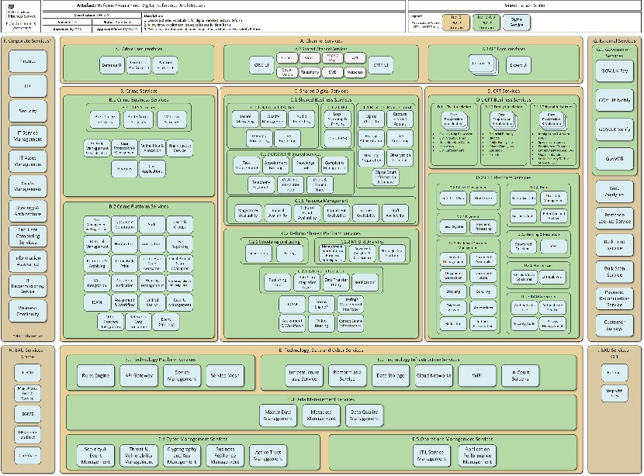The Digital Reference Architecture (DRA) for Reform provides a Portfolio-wide view of the Digital Services being delivered. It is aligned and mapped to the Target Operating Model (TOM) to ensure we are meeting the overall HMCTS business objectives and vision for Reform.

The DRA is *the* statement of digital services that is consistent across the Reform Portfolio. It makes use of carefully selected language and terminology to articulate and manage the digital services it describes – in a common and consistent way.

Digital Services are derived from the Business Capabilities defined in the TOM and are organised based on their jurisdictional usage.

The DRA is used to identify reuse, spot duplication and to fill missing capability.

Please see the appendix for a larger version.

OFFICIAL

Page **28** of **32**

OFFICIAL

Page

**29**

of

**32**



Appendix



Appendix



# Terminology

|  |  |
| --- | --- |
| Term | Definition |
| Reform | The portfolio of work to reform UK justice. Covering the external Civil, Family, Tribunal and Criminal services, the Future Operations, and Future Hearings programme. As well as designing how HMCTS internal business will look and the properties we own and manage. The word Reform is sometimes used to just refer to just CFT, rather than the entire programme. |
| CFT | Civil Family and Tribunals Programme: is delivering a range of digital services to support the resolution of Civil, Family and Tribunal cases fairly and speedily, such as divorces, adoptions and social security |
| CP | Crime Programme: aims for cases to progress through the criminal justice system more efficiently and with reduced delays. It plans to reduce the number of hearings taking place in court  or Common Platform – see below |
| Common  Platform | The technology platform being delivered by the Crime Programme i.e. this will run the end to end Criminal Courts services.  The Common Platform Programme (CPP) was a previous name for the Crime Programme. It is not common across Reform, just the Crime Programme |
| I&O | Infrastructure & Operations – a previous construct used prior to Future Operations and Future Hearings |
| I&E | Infrastructure & Enabling – a previous construct used prior to Future Operations and Future  Hearings |
| CTSC | Courts and Tribunal Service Centres: will be created as the centralised locations for “contact” and the support and administration of cases. These may include some of the case officers, where the judiciary decide it is not necessary for them to be co-located with the judiciary |
| Common Component | A software component that is common across the CFT justification. Shown on the DRA as CFT Platform Services (i.e. Business Audit).  This construct covers only CFT and is a term used locally in the CFT programme, and is not common for all of Reform |
| Digital Service | An atomic “architectural chunk”, which delivers a capability to a customer or to another Service. It would usually be a combination of application, data and infrastructure |
| Shared Digital Service | A Digital Service that is shared across jurisdictions i.e. used by Crime and CFT |
| DRA | Digital Reference Architecture  The representation of the Digital Services being delivered by Reform – mapped and aligned to the TOM |
| TRA | Technical Reference Architecture  The catalogue of the products and components that are in use by Reform services, their status and owner. |
| TOM | Target Operating Model  The representation of HMCTS’ business at each of the Interim States and at End State – showing the business capabilities that will be transformed under the programme. |
| Strategic IDAM | The Identify and Access Management solution for CFT. Separate from Tactical IDAM and does not deliver capability to Crime. |

OFFICIAL

Page **30** of **32**

# Digital Reference Architecture v1.9

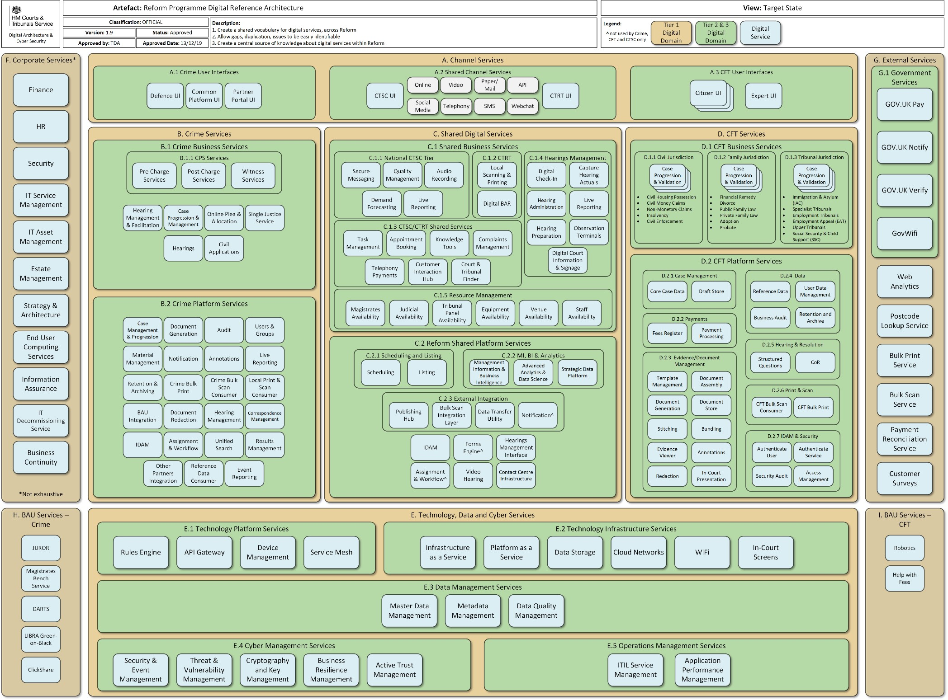

OFFICIAL Page **31** of **32**

# Reform Integration Big Picture (Target)

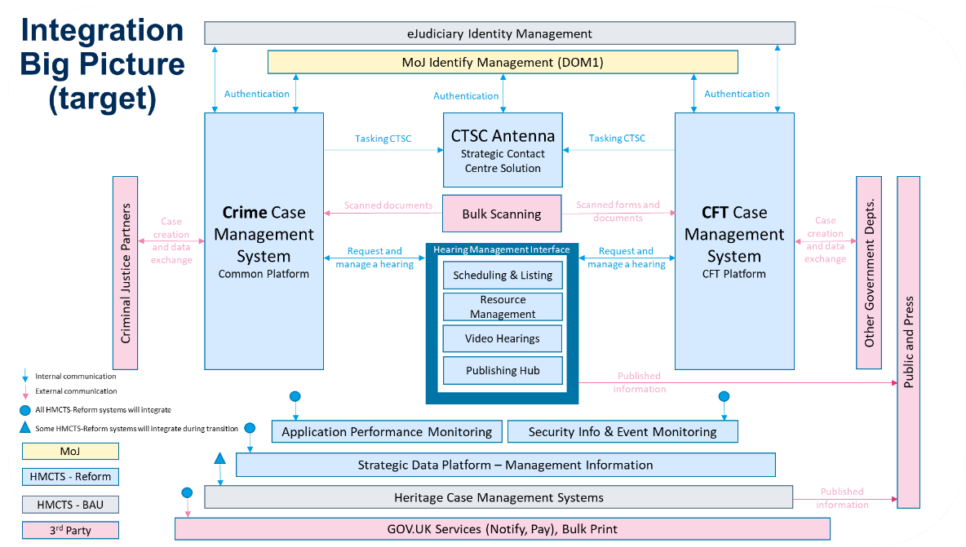

OFFICIAL

Page **32** of **32**

1. S002 Accelerate the digital uptake of our digital services whilst maintaining paper channels
2. S020 Provide tools to the CTSC to enable effective handling of external user queries
3. S003 Invest in tooling to efficiently schedule and list our hearings across our physical and virtual estate
4. S004 Enhance the ability to conduct hearings with remote participation
5. S005 Establish data curation capabilities to ensure we have the data we need, that it is structured and defined properly to enable its use
6. S014 Provide consistent technology standards, patterns, and services to improve reuse, reduce duplication, and improve sustainability
7. S002 Accelerate the digital uptake of our digital services whilst maintaining paper channels
8. S036 Understand staff and end user needs to drive excellent service across everything we do
9. S041 Deliver centralised case management systems to provide tailored case progression for each of our jurisdictions
10. S011 Reduce the technology estate through decommissioning and consolidation to minimise cost and increase supportability
11. S016 Invest in platform and hosting technologies to provide resilience, stability and insight
12. S006 Provide effective data analysis and modelling capabilities to deliver consistent and reliable information and to enable development of new insights
13. S032 Enhance the operating model of DTS to become the centre of excellence for digital change and delivery
14. S038 Take ownership of reformed services, ensuring that they meet the required standards and are actively improved
15. S029 Improve our ability to measure and report on the effectiveness of our digital technology and services
16. S001 Invest in tooling to ensure the effective management and support of our digital estate
17. S039 Provide staff with a single front door for DTS including self-service and personalised technology support
18. S011 Reduce the technology estate through decommissioning and consolidation to minimise cost and increase supportability 19 S010 Implement the migration and archiving of data from heritage systems in order to enable decommissioning.
19. S012 Invest in our heritage IT estate to ensure effective business as usual for our citizens, professional users, and internal users- during and post Reform
20. S013 Improve the user experience of using our local courts and tribunals through effective technology
21. S018 Refresh HMCTS Cyber Security Strategy and implement improvements
22. S024 Develop automated testing of security across our estate
23. S019 Invest in horizon scanning and technology innovation practices to ensure HMCTS is matching pace to technology, societal and legal changes
24. S017 Increase our efficiency through shared capabilities across jurisdictions
25. S008 Invest in data architecture to deliver high quality, efficient and consistent services
26. S005 Establish data curation capabilities to ensure we have the data we need, that it is structured and defined properly to enable its use 28 S006 Provide effective data analysis and modelling capabilities to deliver consistent and reliable information and to enable development of new insights
27. S009 Enhance the ability to share our data to support transparency and enables others to innovate
28. S040 Enhance the integration of our services & platforms to deliver truly end-to-end services
29. S020 Provide tools to the CTSC to enable effective handling of external user queries
30. S003 Invest in tooling to efficiently schedule and list our hearings across our physical and virtual estate
31. S038 Take ownership of reformed services, ensuring that they meet the required standards and are actively improved

    OFFICIAL